Nested try catch blocks

We can write try catch block inside another try block. By having nested try catch blocks, we can separately handle multiple exceptions in the code.  
  
Syntax -  
  
   try  
    {  
             try  
              {   
                 //Code  
               }  
             catch( )  
               {  
                 //Code  
               }  
  
        //Code   
  
     }  
  catch( )  
   {  
      //Code  
   }  
  
Lets implement this on Eclipse IDE -  
  
1. Launch Eclipse IDE, create new Java Project 'Project 47' as shown below -

[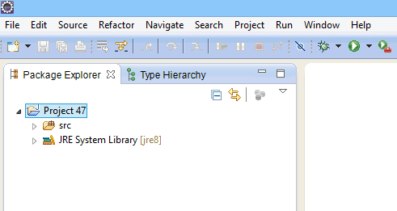](https://2.bp.blogspot.com/-ydweht3RdBI/U_NahxkZ4OI/AAAAAAAAcBM/uG0TDdDn0qo/s1600/1.jpg)

2. Create a new Java Class file 'NestedTryCatchDemo.java' with main( ) method as shown below -

[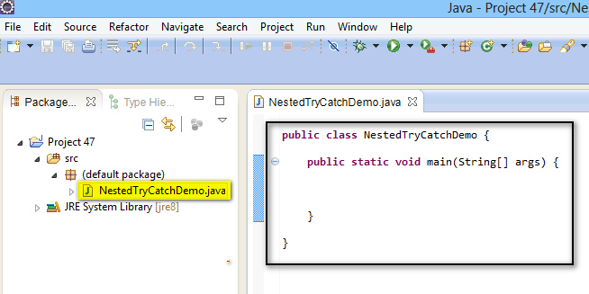](https://2.bp.blogspot.com/-RMiSZOn87-0/U_Na-00OFII/AAAAAAAAcBU/z6PT1rcCeas/s1600/2.jpg)

3. Create a set of statements which can throw more than one exceptions as shown below -

[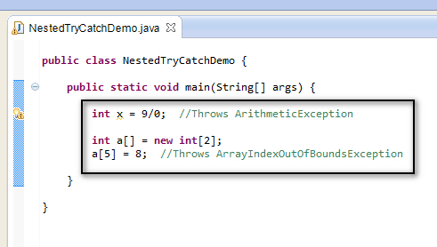](https://1.bp.blogspot.com/-kM_9iH3Y2lw/U_NboJvDzsI/AAAAAAAAcBc/Fli1wDmfv60/s1600/3.jpg)

4. Lets keep the above code in the try block and handle the exception using the catch block as shown below (i.e. Using a single try catch blocks to handle two exceptions)  -

[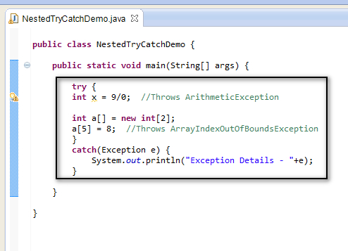](https://3.bp.blogspot.com/-iMjIx7YEDbI/U_NcYFAYToI/AAAAAAAAcBk/WXWaujNgHS8/s1600/4.jpg)

5. Save and Run the Java Class 'NestedTryCatchDemo.java' and observe that only one exception out of two is handled and the exception details are displayed in the output as shown below -

[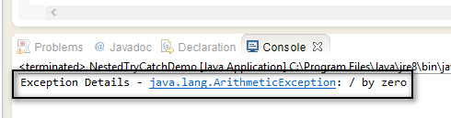](https://4.bp.blogspot.com/-8CU6NsbstlA/U_NctmgvbsI/AAAAAAAAcBs/0Knjbt6oIDI/s1600/5.jpg)

6. Now write another try catch block inside the existing try catch block to handle the first exception separately as shown below -

[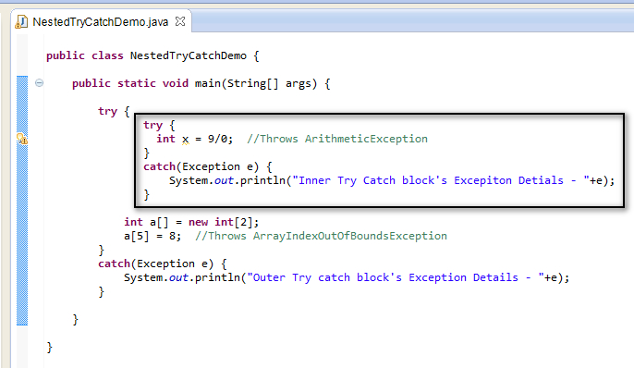](https://3.bp.blogspot.com/-TJRI7CDQInY/U_NdfM3C42I/AAAAAAAAcB0/0kfUF5LwRkU/s1600/6.jpg)

7. Save and Run the Java Class 'NestedTryCatchDemo.java' and observe that two exception out of two are handled and the exception details are displayed in the output as shown below -

[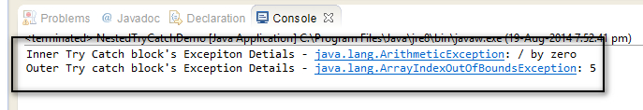](https://4.bp.blogspot.com/-thxKdSClQnU/U_NdxSJ7CsI/AAAAAAAAcB8/WvqDXYhRHFU/s1600/7.jpg)

Hence we can use nested try catch blocks to handle the multiple exceptions separately in the program code.